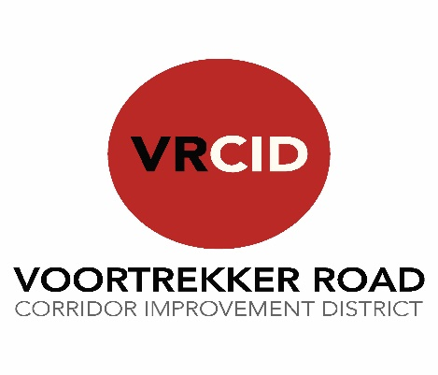

Registration No.: 1996/004458/08
TO BE COMPLETED ONLY BY MEMBERS (OR THEIR DULY AUTHORISED REPRESENTATIVE), OF THE VOORTREKKER ROAD CORRIDOR IMPROVEMENT DISTRICT NPC
PROXY FORM | Initial
I/we ………………………....………………………….………...………… (member name(s)) the registered owner(s)/ member of the registered owner/duly authorised representative of the registered owner (delete whichever is not applicable), of Erf no. …………… at ………………………………… (insert street address), hereby appoint …………………………………………………… (insert name of proxy) as my/our proxy to participate in, speak and vote on my/our behalf at the Annual General Meeting of the Company to be convened at the New National Hotel, Voortrekker Road, Parow on 23 November 2021 at 17:00 or at any adjournment thereof as follows:

Proposed Resolutions |  | In favour of | Against | Abstain
Item  No. | Description

My/our proxy:

shall vote in accordance with my/our wishes, as indicated by the placing of a cross in the appropriate space above;
is not authorised to exercise his/her discretion if this proxy instrument does not give direction in respect of any proposed resolution as per the agenda;
may decide in his/her discretion whether to exercise or abstain from exercising my/our voting right(s) on a matter in respect of which members did not receive advance notice; and
may not delegate his/her authority to act on my/our behalf to another person.

SIGNED at ………………………………………... on this …………. day of 2021

.......................................................... ………………………………………………
Signature Full Names

Notes to proxy form:
- Signed and dated proxy forms (original or electronic copies), must be delivered to the office of the NPC at 3A Bellpark Building, Corner De Lange and Durban Roads, Bellville or transmitted via email to: Leonie.vanderMerwe@vrcid.co.za not less than 24 (twenty-four) hours prior to the time of the meeting.
- No proxy forms will be accepted at the meeting.
- The member(s) shall not be precluded from attending, speaking and voting at the meeting by virtue of lodging this proxy form as aforesaid. In such an event, the member(s) will be deemed to have revoked the proxy appointment.
- Any alteration to this proxy form must be initialled by the signatory(ies).

