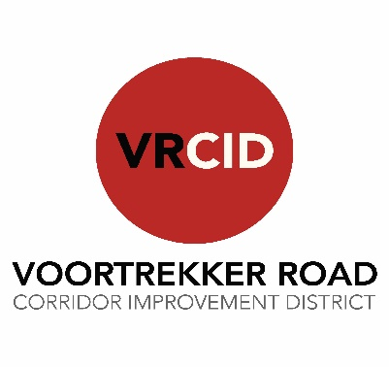
BALLOT FORM
FOR VOORTREKKER ROAD CORRIDOR IMPROVEMENT DISTRICT NPC (VRCID) ANNUAL GENERAL MEETING HELD ON TUESDAY, 21 NOVEMBER 2023 AT THE NEW NATIONAL HOTEL, VOORTREKKER ROAD, PAROW
Number of votes exercised on the special resolution for the amendment of the MOI: ……..
Property Owner`s Name: …………………………………….
Authorised Representative, if applicable: …………………………………………………………
ERF Number(s): ……………………………..

Proposed Resolutions |  | In favour of | Against | Abstain
Item  No. | Description
14. | Special Resolution: Amendment of the new Memorandum of Incorporation (MOI) the Voortrekker Road Corridor Improvement District NPC as contemplated in Section 16(5)(a) of the Companies Act, Act 71 of 2008.

__________________________
Signature

