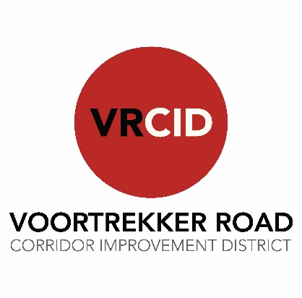
Notice of Annual General Meeting (AGM)
The Voortrekker Road Corridor Improvement District NPC (VRCID) will be hosting an AGM. All stakeholders are invited to a review of the past financial year’s activities and planning for 2026/27.

Date: Tuesday, 18 November 2025
Place
CID emblem
here
Time: 16:00
Venue: VW McCarthys, 270 Voortrekker Road, Parow

Resolutions presented at the meeting can only be voted on by bona fide members of the VRCID. This membership is available free of charge to all owners of property within the VRCID footprint who are liable for the additional rate (additional rate payers), but they must be registered before 11 November 2025.

To register as a member or access further information and documentation go to www.vrcid.co.za or call 021 823 6713

