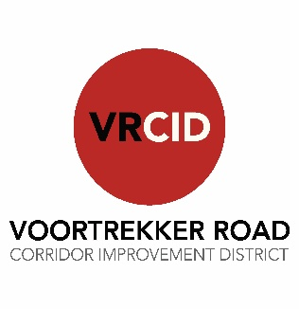
BALLOT FORM
FOR VOORTREKKER ROAD CORRIDOR IMPROVEMENT DISTRICT NPC (VRCID) ANNUAL GENERAL MEETING HELD ON TUESDAY, 18 NOVEMBER 2025 AT VW MCCARTHY’S, 270 VOORTREKKER ROAD, PAROW

Number of votes exercised on the proposed resolution: ……..

Property Owner`s Name: …………………………………….
Authorised Representative, if applicable: …………………………………………………………
ERF Number(s): ……………………………..

Proposed Resolutions |  | In favour of | Against | Abstain
Item  No. | Description | In favour of | Against | Abstain

__________________________
Signature

